**Lab – 38: How to** **get started with enrolling devices in Microsoft Intune?**

**Objective:** The objective of this lab is –

* To get started with enrolling devices in Microsoft Intune.

Microsoft Intune helps you enable your workforce with mobile devices while keeping your corporate data protected. Enrolling a device is the first experience that many end users will have with accessing corporate resources. In this lab, we’ll use App store for Company Portal app installation and Intune enrollment.

**Prerequisite:** EMS Enterprise Mobility + Security E5.

**Steps:**

1. Open the **App Store** and search for **Intune Company Portal**. Company portal is basically an app that lets you, as an employee of your company, securely access resources like - Office, Email and OneDrive for business. Before you can use this app, make sure your IT Admin has set up your work account. Your company must also have a subscription to Microsoft Intune.

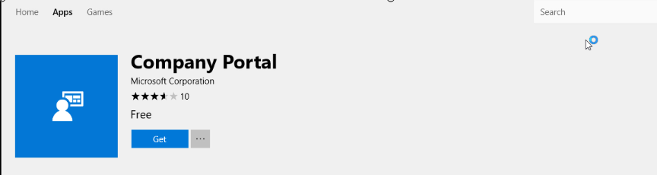

1. Download and install the **Microsoft Intune Company Portal app**.
2. Now **launch** the app. Sign-in to your Work or school account. Enter your user’s email address and password, then tap **Sign in**.

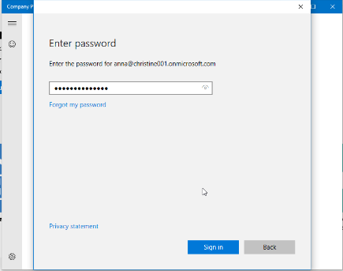

1. Once you signed-in, it will add your account to Windows. Then click **Yes**. Or if you don’t want to add this account to Windows, click **Skip for now**.

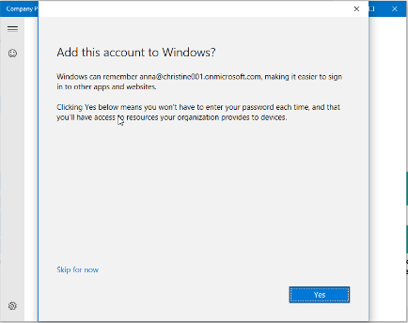

1. Now hold for a moment your device is registering with your company and applying policy.
2. You will get You’re all set confirmation page. Click **Done**.

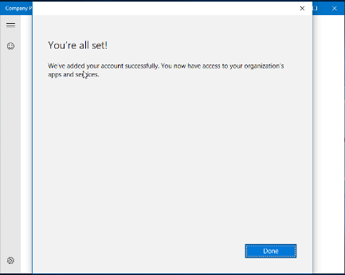

1. If your device hasn’t been set for corporate use, you can select this message to begin the setup.

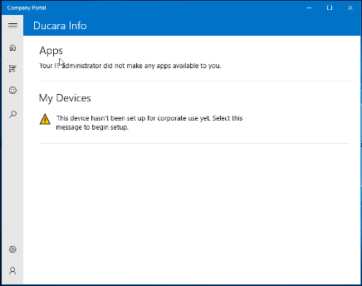

1. Now, set up your device for use with your company. So, we have added corporate account to this device. Now, we have to enroll this device into management. Click **Next**.

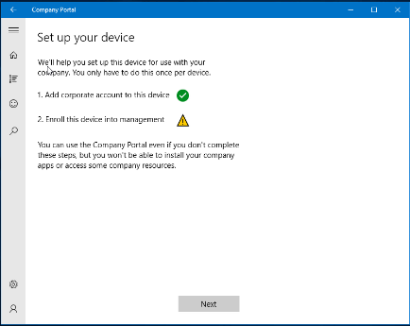

1. In the Enroll into management page, select **Enroll this device**.

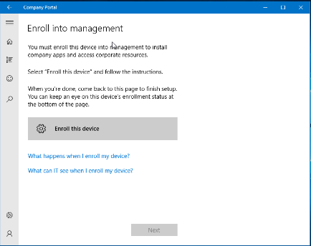

1. Enter your work account and click **Next**.

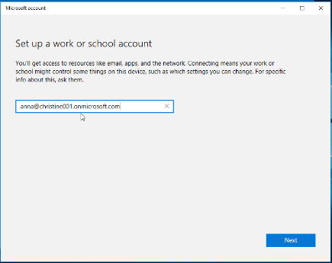

1. Connecting to a service page will open. Enter your Microsoft Intune Enrollment credentials. Click **Sign-in**.

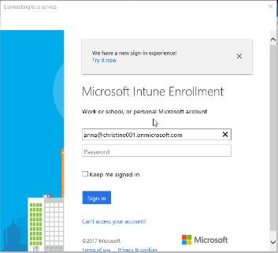

1. After sign-in, you will get **Almost finished…** notification page. Click **OK**.

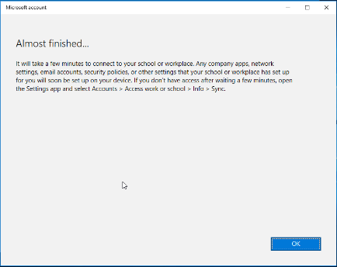

1. Then, in Enroll into Management page you will get notification at the below of the page that **Your device is now Enrolled**. Select **Next** to continue.

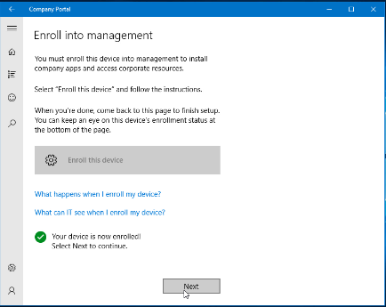

1. Then click **Done**, on the You’re all set page. And, here you can see the enroll this device into management is also showing green.

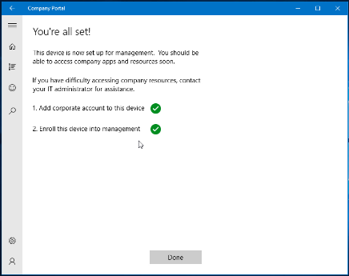

1. If view policy issues pop-up will appear, click **Postpone**.

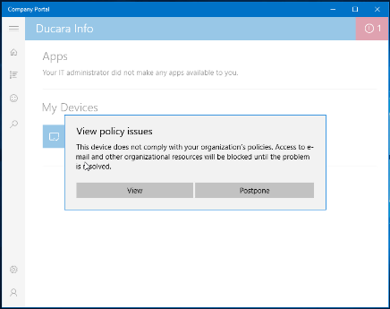

1. And, now you can see the device details. Click **Check Compliance**, to check the device for compliance. It will take few minutes to check. After completion you will get the **policy compliance status** is **In Compliance**.

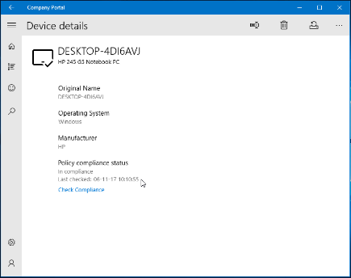

1. You can go to home and check the **Apps** and **Devices** details.

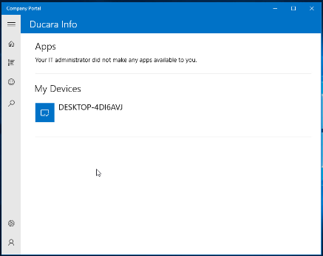

1. So, in this way you can get started with enrolling devices in Microsoft Intune.